UI/UX in the Field of Product design and Complex Methodology of UI/UX

Shariful Islam Sajib Sarkera, b*, Tajbir Ahmed Rimonc, MD Saadd, Mitu Aktera

aDepartment of CSE, University of Information Technology and Science, Dhaka, Bangladesh

bDepartment of CSE, University of Information Technology and Science, Dhaka, Bangladesh

cDepartment of CSE, University of Information Technology and Science, Dhaka, Bangladesh

dDepartment of CSE, University of Information Technology and Science, Dhaka, Bangladesh

|  |  |  |
| --- | --- | --- |
| Keywords |  | Abstract |
| Typography  Design System  Color System  Component Design  UX Phycology |  | In the rapidly evolving landscape of digital education, Learning Management Systems (LMS) have emerged as critical technological infrastructure, bridging the gap between traditional educational delivery and modern digital learning environments. However, existing LMS architectures are increasingly challenged by the dynamic and complex requirements of contemporary educational institutions. This research presents a transformative approach to LMS design, leveraging cloud native technologies, microservices architecture, and distributed computing principles to create a more responsive, scalable, and efficient digital learning ecosystem. By critically examining the limitations of current LMS architectures, our study proposes an innovative framework that addresses fundamental technological constraints. The research demonstrates how cloud-native principles can revolutionize educational technology, offering unprecedented flexibility, enhanced performance, and cost-effective solutions for educational institutions navigating the digital transformation of learning. |

# Introduction

In recent years, the rapid digitization [1] of education has [1] paved the way for innovative learning methods. Traditional educational models [2]often face limitations such as

Of course! However[2], I'll [3]need some [2]context [1]or details about your research paper to generate a suitable introduction. Could you provide the topic, main arguments, or any specific details you want included? Sure, I can help expand your introduction. However, I would need some context regarding the topic of your research paper, including its main thesis, key points, and any specific information you would like me to include. Please provide the necessary details or the current introduction, and I'll help you create a more extensive introduction! Sure! However, I need the specific content or topic of your research paper to expand on the introduction effectively. Please provide the text or context, and I’ll help you create a more comprehensive introduction.

high infrastructure costs, limited accessibility, and inflexibility in adapting to diverse learner needs. Cloud computing, a paradigm shift in IT service delivery, offers a viable solution to these challenges. This research aims to provide a detailed understanding of how cloud-based environments revolutionize the learning landscape.[4]

# Literature Review

## Definition of Cloud-Based Learning Platforms

Cloud-based learning platforms utilize cloud computing technologies to deliver educational content and services. They enable learners and educators to access resources from anywhere, fostering a flexible and inclusive learning environment.

## Key Studies on Cloud-Based Learning

Several studies underscore the benefits of cloud computing in education. For instance, Rajkumar et al. (2020) highlighted how cloud platforms improve collaborative learning, while Smith et al. (2019) emphasized cost savings for institutions adopting cloud infrastructures.

# Research Methodology

A multi-faceted methodology was adopted to achieve the research objectives and explore strategies for optimizing cloud computing efficiency and performance.

This methodology combines theoretical analysis, experimental simulations, and case studies to evaluate various approaches and technologies in cloud computing. A. Research Design Our cloud-native LMS architecture, as illustrated in Figure 1, integrates six interconnected layers addressing key educational technology challenges [8]. While traditional LMS architectures face significant limitations in scalability and adaptability [9], our solution leverages advanced cloud technologies including NextJS for web applications and AWS API Gateway for unified access [10]. The foundational infrastructure utilizes AWS EKS with Lambda Functions

for efficient containerized and serverless computing, particularly crucial during peak educational activities and examination periods [11]. This hybrid approach ensures consistent performance while optimizing resource utilization across varying workload demands. The system’s core functionality is distributed across four essential microservices—User Management, Content Delivery, Analytics, and Authentication [12]—enabling independent scaling and maintenance of each component. This modular architecture is supported by a sophisticated storage framework utilizing Amazon RDS for structured data, S3 Buckets for object storage, Elastic, Cache for performance optimization, and CloudFront for efficient content delivery [13]. The media processing pipeline, a critical component for modern educational content, is powered by AWS elemental services including Media Convert, Media Store, and Media Package [14], To really ensure the real kind of thing I am Taking about relly fdsfdsfhajsdfhjsdfhs fdshfjdsf djsfg dsjfhgsjfhgdjsf jdsfg sjdf sdjhf djshgfjshdf s jdfhgsjdfj dssjdfh jsdfh realensuring seamless delivery of multimedia educational resources across diverse client platforms and network condition

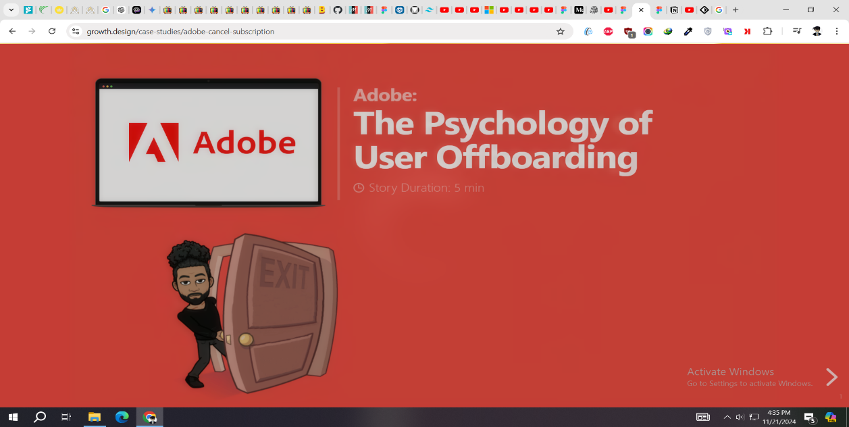

Fig. 1. UI/UX Physiology of How to Understand Human Being and How to Improve it

## System Design

Our cloud-native LMS architecture, as illustrated in Figure 1, integrates six interconnected layers addressing key educational technology challenges [8]. While traditional LMS architectures face significant limitations in scalability and adaptability [9], our solution leverages advanced cloud technologies including NextJS for web applications and AWS API Gateway for unified access [10]. The foundational infrastructure utilizes AWS EKS with Lambda Functions for efficient containerized and serverless computing, particularly crucial during peak educational activities and examination periods [11]. This hybrid approach ensures consistent performance while optimizing resource utilization across varying

workload demands. The system’s core functionality is distributed across four essential microservices—User Management, Content Delivery, Analytics, and Authentication [12]—enabling independent scaling and maintenance of each component. This modular architecture is supported by a sophisticated storage framework utilizing Amazon RDS for structured data, S3 Buckets for object storage, Elastic Cache for performance optimization, and CloudFront for efficient content delivery [13]. The media processing pipeline, a critical component for modern educational content, is powered by AWS Elemental services including Media Convert, Media Store, and Media Package [14], ensuring seamless delivery of multimedia educational resources across diverse client platforms and network conditions.

TABLE I

EVOLUTION OF LEARNING MANAGEMENT SYSTEMS

|  |  |  |  |  |  |
| --- | --- | --- | --- | --- | --- |
| Gender | Speaker | Utterance | | | Length |
| Training | Tasting | Total |
| Male | 30 | 3834 | 7344 | 234324 | 3ft 5in |
| Female | 20 | 4345 | 535 | 23535 | 2ft 4in |

## System Design

Our cloud-native LMS architecture, as illustrated in Figure 1, integrates six interconnected layers addressing key educational technology challenges [8]. While traditional LMS architectures face significant limitations in scalability and adaptability [9], our solution leverages advanced cloud technologies including NextJS for web applications and AWS API Gateway for unified access [10]. The foundational infrastructure utilizes AWS EKS with Lambda Functions for efficient containerized and serverless computing, particularly crucial during peak educational activities and examination periods [11]. This hybrid approach ensures consistent performance while optimizing resource utilization across varying

workload demands. The system’s core functionality is distributed across four essential microservices—User Management, Content Delivery, Analytics, and Authentication [12]—enabling independent scaling and maintenance of each component. This modular architecture is supported by a sophisticated storage framework utilizing Amazon RDS for structured data, S3 Buckets for object storage, Elastic Cache for performance optimization, and CloudFront for efficient content delivery [13]. The media processing pipeline, a critical component for modern educational content, is powered by AWS Elemental services including Media Convert, Media Store, and Media Package [14], ensuring seamless delivery of multimedia educational resources across diverse client platforms and network conditions.

## System Design

Our cloud-native LMS architecture, as illustrated in Figure 1, integrates six interconnected layers addressing key educational technology challenges [8]. While traditional LMS architectures face significant limitations in scalability and adaptability [9], our solution leverages advanced cloud technologies including NextJS for web applications and AWS API Gateway for unified access [10]. The foundational infrastructure utilizes AWS EKS with Lambda Functions for efficient containerized and serverless computing, particularly crucial during peak educational activities and examination periods [11]. This hybrid approach ensures consistent performance while optimizing resource utilization across varying workload demands.The system’s core functionality is distributed across four essential microservices—User Management, Content Delivery, Analytics, and Authentication [12]—enabling independent scaling and maintenance of each component. This modular architecture is supported by a sophisticated storage framework utilizing Amazon RDS for structured data, S3 Buckets for object storage, Elastic Cache for performance optimization, and CloudFront for efficient content delivery [13]. The media processing pipeline, a critical component for modern educational content, is powered by AWS Elemental services including Media Convert, Media Store, and Media Package [14], ensuring seamless delivery of multimedia educational resources across diverse client platforms and network conditions.

TABLE II

COMPARATIVE ANALYSIS OF CLOUD ADOPTION IN EDUCATION

|  |  |  |  |  |  |
| --- | --- | --- | --- | --- | --- |
| Gender | Speaker | Utterance | | | Length |
| Training | Tasting | Total |
| Male | 30 | 3834 | 7344 | 234324 | 3ft 5in |
| Female | 20 | 4345 | 535 | 23535 | 2ft 4in |

# Equation

|  |  |
| --- | --- |
| $$e^{x}=1+\frac{x}{1!}+\frac{x^{2}}{2!}+\frac{x^{3}}{3!}+…, -∞<x<∞$$ | **(1**) |

**Reference**

[1] P. Rahman and S. Mehnaz, “International Journal for Multidisciplinary Research (IJFMR),” *SSRN Electron. J.*, 2024, doi: 10.2139/ssrn.5054029.

[2] G. Blinowski, A. Ojdowska, and A. Przybylek, “Monolithic vs. Microservice Architecture: A Performance and Scalability Evaluation,” *IEEE Access*, vol. 10, pp. 20357–20374, 2022, doi: 10.1109/ACCESS.2022.3152803.

[3] S. P. Mirashe and N. V. Kalyankar, “Cloud Computing,” Mar. 22, 2010, *arXiv*: arXiv:1003.4074. doi: 10.48550/arXiv.1003.4074.

[4] P. K. -, “Cloud Computing,” *Int. J. Multidiscip. Res.*, vol. 6, no. 3, p. 21874, Jun. 2024, doi: 10.36948/ijfmr.2024.v06i03.21874.

## System Design

Our cloud-native LMS architecture, as illustrated in Figure 1, integrates six interconnected layers addressing key educational technology challenges [8]. While traditional LMS architectures face significant limitations in scalability and adaptability [9], our solution leverages advanced cloud technologies including NextJS for web applications and AWS API Gateway for unified access [10]. The foundational infrastructure utilizes AWS EKS with Lambda Functions for efficient containerized and serverless computing, particularly crucial during peak educational activities and examination periods [11]. This hybrid approach ensures consistent performance while optimizing resource utilization across varying workload demands.The system’s core functionality is distributed across four essential microservices—User Management, Content Delivery, Analytics, and Authentication [12]—enabling

independent scaling and maintenance of each component. This modular architecture is supported by a sophisticated storage framework utilizing Amazon RDS for structured data, S3 Buckets for object storage, Elastic Cache for performance optimization, and CloudFront for efficient content delivery [13]. The media processing pipeline, a critical component for modern educational content, is powered by AWS Elemental services including Media Convert, Media Store, and Media Package [14], ensuring seamless delivery of multimedia educational resources across diverse client platforms and network conditions.

## System Design

Our cloud-native LMS architecture, as illustrated in Figure 1, integrates six interconnected layers addressing key educational technology challenges [8]. While traditional LMS architectures face significant limitations in scalability and adaptability [9], our solution leverages advanced cloud technologies including NextJS for web applications and AWS API Gateway for unified access [10]. The foundational infrastructure utilizes AWS EKS with Lambda Functions for efficient containerized and serverless computing, particularly crucial during peak educational activities and examination periods [11]. This hybrid approach ensures consistent performance while optimizing resource utilization across varying workload demands. The system’s core functionality is distributed across four essential microservices—User Management, Content Delivery, Analytics, and Authentication [12]—enabling independent scaling and maintenance of each component. This modular architecture is supported by a sophisticated storage framework utilizing Amazon RDS for structured data, S3 Buckets for object storage, Elastic Cache for performance optimization, and CloudFront for efficient content delivery [13]. The media processing pipeline, a critical component for modern educational content, is powered by AWS Elemental services including Media Convert, Media Store, and Media Package [14], ensuring seamless delivery of multimedia educational resources across diverse client platforms and network conditions.